Report on Soccer at Future Hope for the Rory Trust
Soccer Program
Soccer at Future Hope is played as part of a group of Winter sports. In the case of boys, it is a minor sport in comparison to Rugby, while girls enjoy Hockey and Netball as well. It is also a sport that is represented best at the senior levels which matches the emphasis in external competitions in Kolkata.
In a small school, we compromise in order to offer the range of sports we do. We encourage this in the interests of developing good motor skills and knowledge of games, plus enhancement of fitness and enjoyment. We are investigating the appointment of a qualified soccer coach for 2014-15. It is to be hoped that a skill-based program can be established to raise the standard of practice sessions.
Soccer squads and teams are listed on the School Noticeboard, approved by the Head of Sport and Principal.
General Participation
External fixtures are not always predictable. The following are the major external tournaments:
- The Keventer Cup is played in June and July for U19 boys and girls.
- Interschool Soccer Tournament, organised by Kolkata Police, is played in August for U 19 boys and girls.
- The Devanjan Foundation for Girls U 19 is usually held at La Martiniere Girls.
All tournaments are knock-out by nature. We wait for invitations to be sent out. Each player is then registered by photograph and proof of age via each school administration. In these competitions we field one team for boys and girls.
House Sport
During the season that runs from May to September there will be a minimum of six (6) House fixtures that make-up part of the T C Dutt Trophy. These matches are played at the Maidan. House fixtures are played on either a Tuesday or Thursday. We have already played Round 1 among the four houses: Cobra, Elephant, Panther and Tiger. House fixtures are managed by house leaders and supported by staff. Given the present number of players, we often combine capable juniors with seniors. House Soccer is also played in a four-aside version in our backyard synthetic grass area. These games are arranged by houses when time is available.

Soccer Practice and Numbers
Tuesday and Thursday practice sessions from 4 to 6 are held throughout the season at the Maidan. At present, we have approximately 20 boys participating in the U16-U19 age range. In the same category for girls there are 12. Physical Education classes also incorporate some Soccer sessions.

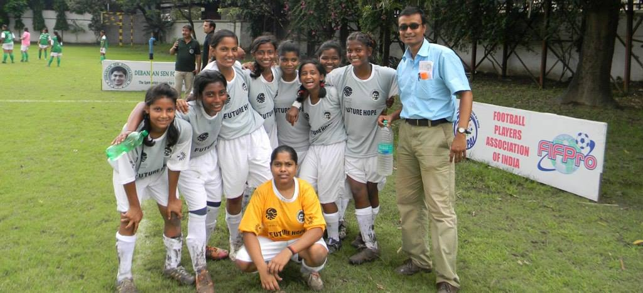
The Senior Girls’ Soccer Team finished Runners’ Up in the Devanjan Foundation Cup at La Martiniere 2013

